**4-Binary Trees**

*Note*:  You can select and do some options according to your ability only. We would like to note you that the more questions you do the better for you in doing final practical  and writing exams.

**Writing exercises**  
1.   Give the preorder, inorder, postorder,and level-order traversals of the following binary trees.  
(a)  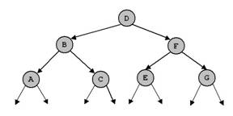(b)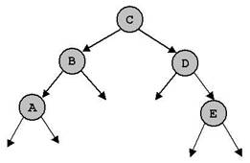     
(c) 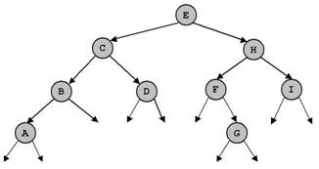

 2.   For each of the following key sequences create the binary search tree obtained when the keys are inserted one-by-one in the order given into an initially empty tree:  
(1) 4, 3, 1, 11, 5, 9, 2, 6, 15, 12.  
(2) 12, 7, 1, 3, 2, 5, 10, 8, 6, 9.  
      Give the preorder, inorder, postorder,and level-order traversals of the created binary trees.  
      In (1) delete keys 2, 3 and 11. In (2) delete keys 5, 6 and 7. After each time of deleting, give the above traversals.  
   
3.   For each of the  key sequences in question 2 create the AVL tree obtained when the keys are inserted one-by-one in the order given into an initially empty tree.  
      Give the preorder, inorder, postorder,and level-order traversals of the created binary trees.

4.   The  tree  (c) in question 1 is height balanced (AVL). Delete the node  D  and perfom necessary operations so that the tree is still AVL after deletion.

5.   Consider a *nearly complete* binary tree with *n* nodes.  
a. For what values of  *n* is a nearly complete binary tree a  *full* binary tree?  
b. For what values of  *n* is a nearly complete binary a complete (*perfect)* binary tree?

6.   Suppose we have numbers between  1  and  100 in a binary search tree and we want to search for the number 57 in the tree. Could the following sequence be the sequence of nodes to be examined?  
2, 90, 63, 70, 68, 72, 57

**Practical exercises**  
**Question 1.** Write a Java program to implement a binary search tree of integer values with the following operations:  
1.   boolean isEmpty() -   return true if a tree is empty, return false otherwise.  
2.   void clear() - clear a tree.  
3.   Node search(int x) - Search a node having value x. Return a reference to that node if found, return null otherwise.  
4.   void insert(int x) - check if the key x does not exists in a tree then insert new node with value x into the tree.  
5.   void breadth() - traverse a tree.  
6.   void preorder(Node p) - recursive preorder traverse of a tree.  
7.   void inorder(Node p) - recursive inorder traverse of a tree.  
8.   void postorder(Node p) - recursive postorder traverse of a tree.  
9.   int count() - count and return number of nodes in the tree.  
10. void dele(int x) - delete a node having value x.  
11. Node min() - find and return the node with minimum value in the tree.   
12. Node max() - find and return the node with maximum value in the tree.   
13. int sum() - return the sum of all values in the tree.   
14. int avg() - return the average of all values in the tree.  
15. The height of a tree is the maximum number of nodes on a path from the root to a leaf node. Write a  function that returns the height of a binary tree.  
16. The cost of a path in a tree is sum of the keys of the nodes participating  in that path. Write a  function that returns the cost of the most expensive  path from the root to a leaf node.  
17. Write a  function to determine whether a given binary tree is AVL or not.  
18. What value does the following function return when called with each of the binary trees in question 3?  
int mystery(Node x) {  
if (x == null)  
return 0;  
else  
return max(mystery(x.left), mystery(x.right));  
}  
19. Write a  function to determine whether a given binary tree is a heap.

**Question 2.** Write a Java program to implement a binary search tree of  string values with operations in the above list.